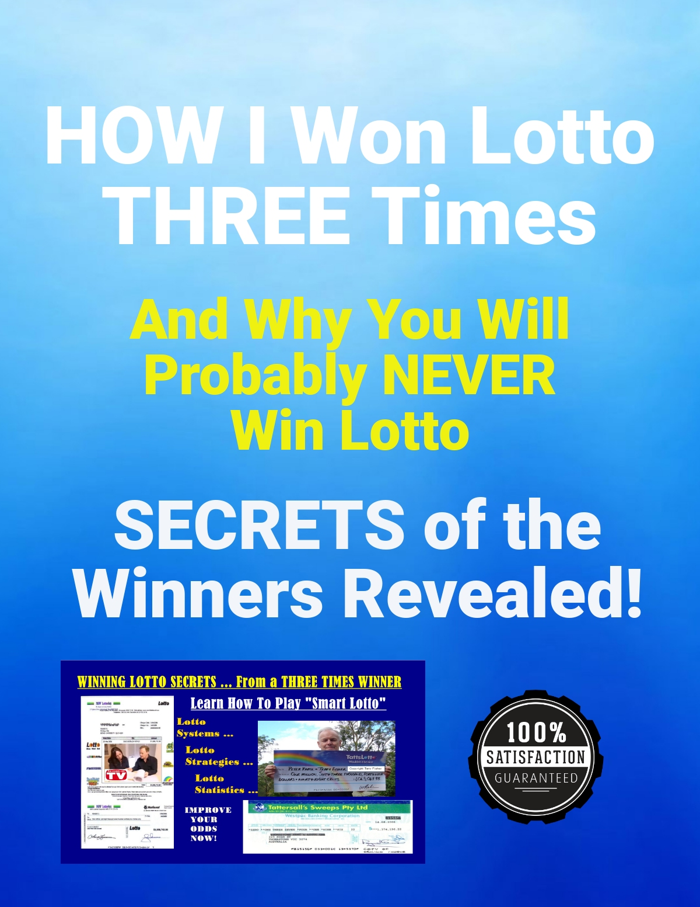

HOW SMART PEOPLE PLAY THE LOTTERY

There is a reason why Olympic athletes are Olympians, why Nobel winning scientists achieve things people thought were impossible, why concert musicians attain world class standards –
They do things that other people will NOT do.
They train harder, often for hours a day, several days a week; they ask questions that other people never even think of, they practise, practise some more, and then just for good measure practise even harder.
The same is true for playing Lotto.
What I am prepared to do to win Lotto is probably
way ahead of what you are prepared to do. I work
many hours a week refining what I already know.
This is why I have won the lottery three times and you probably have never had even one First Prize
So, if you are serious about winning Lotto, you only have to choices.
- The first is to work as hard and as long as I do.
- The second, much easier, way is to either learn from me or work with me.
So, let's have a look at what I know, which falls into two categories.

The first is creating what I call “Must Win Something Lotto Systems.” So, what does that mean?
As an example, for our Australian Pick 6 - 45 ball lottery I have created a 160-game entry that guarantees three of the six winning numbers, no matter what numbers are drawn.
This gets us 50% of the way there and also
guarantees a small win no matter what. This
also allows us to “Play Lotto at a Discount”
every week except the first week.
The starting point for this is examining the winning structure for the lottery in question; this can be done for any lottery worldwide.
For our Australian 6/45 lottery, three winning numbers guarantees a prize, no matter how small, and is halfway towards getting all six winning numbers.
I have also created a lottery system guaranteeing 4 winning numbers for any 6/45 lottery in 3,350 games.

Now you can also spend many hours creating your own lottery systems that will get you at least half of the winning numbers every time you play - or you can ask us to do it for you. And, as you will learn later, there is a way we will do this for you free of charge.
However, playing 3350 games, or even 160 games, is something we do not recommend for individual players. The second part of our strategy is putting together small Lotto groups.
This is the part where it becomes too hard for most people. But the only sensible way to play even 160 games is sharing the cost between 8 to 12 people.
If asking friends, family or work colleagues to significantly improve their chances of winning Lotto by joining together to fund a joint entry is too hard, you can probably stop reading now.

Not only does a highly organised, systematic entry improve your chances of winning Lotto, sharing first prize with others is actually good for your health. What? I know, give me First Prize and I will take my chances. However, if you check the Internet you will find stories where winning the lottery is the worst thing that ever happened to people, including in some cases death.
My three First Prizes have been shared with 19 others. If the first prize is “only” a Million, you still get $50,000. If the lottery is jackpotted to 20 million, you get $1,000,000. Being practical and putting together a highly organised entry, with a guaranteed result, is the way to go.

Getting your “Must Win Something” entry for free is very simple. You need to send me a form signed by all members of your syndicate stating that they all agree that I will become a member of the syndicate at no cost, on an ongoing basis, and share equally in all wins.
Before you do this, I would suggest sending an email to me at terry.aust@gmail.com and I can give the group feedback. Indicating to me the amount each individual member can comfortably afford is a good start - I can then give you options for the best way to create our system. I also obviously need to know which lottery you play. As you will see, particularly with the second strategy, different approaches to fit any budget are possible.

As with most things in life, cooperating with others with different gifts is the way to go.

We can also put together a strategy for playing 5-ball lotteries, including games like Powerball and Mega Millions. We also cover 7 ball lotteries - The first step, as with most things, is starting the conversation.

As I indicated earlier, there is a second way to go about this. The advantage of this second strategy is that it is adaptable to just about any budget.
This involves play all the numbers in your lottery with multiple system entries. At its very simplest, this is best explained by 7 system 7 entries for a 49-ball lottery, pick 6. Here is an example:
1 2 3 4 5 6 7
8 9 10 11 12 13 14
15 16 17 18 19 20 21
22 23 24 25 26 27 28
29 30 31 32 33 34 35
36 37 38 39 40 41 42
43 44 45 46 47 48 49
Please – do NOT play this. I use 1 to 49 ONLY to illustrate the concept. Six consecutive numbers have NEVER been drawn in any lottery worldwide.
You can use the above table to tick off All 49 numbers as you create them in a more sensible arrangement.

We have sophisticated analysis systems allow us the best possible spread of numbers. For example, the most drawn Odds and Evens type is 3 odd - three even, so we ensure that every set of 7 numbers includes at least 3 odd numbers and three even numbers.

However, sophisticated analysis systems that we have enable us to look for which pairs of numbers come out together, along with many other types of result that come out regularly.
You can if you wish create seven different system sevens, using all 49 numbers, if you play a 49-ball lottery, without using our services.
However, if you are playing a 7-ball lottery we do have systems for creating seven number entries. For example, in Australia's Oz Lotto game, we have created a system that guarantees four of the seven winning numbers together in just 505 games.
This can just as easily be played in a 6-ball lottery using multiple system 7’s.
We also do multiple system 8’s, 9’s and 10’s. If you check out the section on System Entries, you will see but after system 10s it becomes prohibitive to use multiple systems. This is because the growth in the number of games played is not linear; a system 8 requires 28 games, whereas a system 12 requires 924 games.
Put another way, you have a choice of one system 12 or 33 system 8’s - both of which require paying for 924 games. One system 12 does not guarantee you will get any winning numbers. Nor in fact does 33 system 8's BUT you can use all 49 numbers (for example) EIGHTEEN times – which do you think is the smarter play?
For multiple system 9’s, you can play the equivalent of 11 system 9’s in 924 games, and for multiple system 10s you can play 4 different system 10s in 840 games. This is why we normally recommend systems 7, 8, 9 and 10 but nothing bigger.
There is a trade-off here, which is up to your Lotto group members. With a system 9, you can get 1/3 of the numbers wrong and still end up with all six winning numbers!
Whatever options you decide upon, we can then make an arrangement of the numbers in a way that corresponds to what happens most of the time with actual results.

IMPORTANT: While our first strategy (e.g, 160 games in a 45-ball lottery guaranteeing a win of at least three numbers) does give a guaranteed payout - multiple full system entries do NOT.
For example, in our Australian 45 ball lottery, nine different system 10’s guarantees we have all of the winning numbers twice, BUT there is no guarantee they will line up to give us a win. The advantage is playing sets of ten numbers, rather than individual games of 6 numbers.

INDIVIDUAL PLAYERS: Despite what we have said, some people will still choose to play on their own. The smartest way to do this is using what we call “Abbreviated Lotto Systems.” An example is that a Full System 8 requires 28 games – But if you play your 8 numbers as FOUR PAIRS then if any 3 pairs contain the six winning numbers, you have FIRST PRIZE – in just FOUR Games! This also enables playing several sets of 8 numbers.
Playing 9 numbers as 3 TRIO’s is equally effective.

To get INDIVIDUAL lottery strategies – please visit
http://www.FreeLottoSecrets.com and Sign Up.
You will receive via email several free lottery reports, a few days apart, with actual lottery systems and templates for your own numbers. These include 8, 9, 10, and 12 number systems. Following the Lotto Systems series, there are Reports on how to improve your Lotto Playing Techniques.

OTHER LOTTO RESOURCES – PLAY SMART!
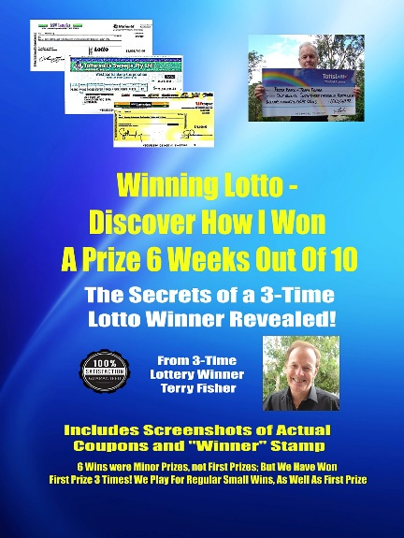 | www.WinningLottoBooks.com  Winning Lotto Secrets From  a 3-Time Lottery Winner  157 pages of proven Lotto Systems, Strategies & Statistics.  Secret Strategies known only to the Pro’s and  TWENTY-SIX mind-blowing lotto systems
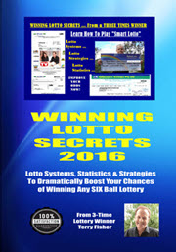 | www.WinningLottoBooks.com  Winning Lotto 6 Weeks Out Of 10 -  The Secrets Revealed.  Almost everyone has the wrong Winning Lotto Strategy! Let’s take a different look at Winning Lotto Strategies. Includes screen shots of the coupons for 10 consecutive weeks – And how I got a small prize 6 of the 10 weeks!  Learn how to Play Lotto at a Discount!
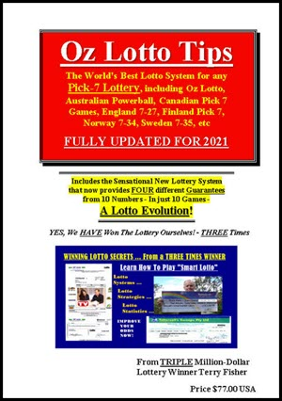 | www.OzLottoTips.com  Suitable for Any 7-Ball Lottery Worldwide.  Includes an Abbreviated System 9 that saves 30 games, Plus an Abbreviated System 10 that saves 110 games – The SMARTEST way to play any 7-ball Lottery.  Both Systems have FOUR different Guarantees and are inexpensive to play.

